**HEALTHCARE ANALYSIS SQL**

**1. Total Patients**

**SELECT COUNT(*) AS PATIENTS**

**FROM HEALTH**

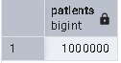

**2. Total Revenue**

**SELECT SUM(BILL_AMOUNT) AS TOTAL_REVENUE**

**FROM HEALTH**

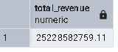

**3. Average Bill per Patient**

**SELECT AVG(BILL_AMOUNT) AS AVG_BILL**

**FROM HEALTH**

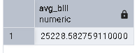

**4. Patients by Hospital**

**SELECT HOSPITAL_NAME, COUNT(PATIENT_ID) AS PATIENTS**

**FROM HEALTH**

**GROUP BY HOSPITAL_NAME**

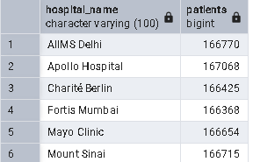

**5. Patients by Department**

**SELECT DEPARTMENT, COUNT(PATIENT_ID) AS PATIENTS**

**FROM HEALTH**

**GROUP BY DEPARTMENT**

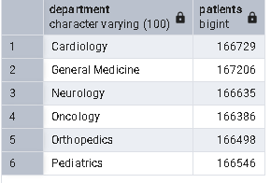

**6. Top 5 Diagnoses**

**SELECT DIAGNOSIS, SUM(BILL_AMOUNT) AS TOTAL**

**FROM HEALTH**

**GROUP BY DIAGNOSIS**

**ORDER BY TOTAL DESC**

**LIMIT 5**

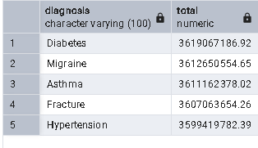

**8. Monthly Visit Trend**

**SELECT TO_CHAR(VISIT_DATE, 'YYYY-MM') AS MONTH, COUNT(*)**

**FROM HEALTH**

**GROUP BY MONTH**

**ORDER BY MONTH ASC**

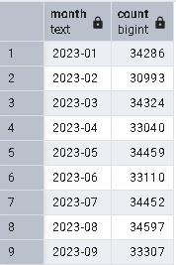

**10. Insurance Utilization**

**SELECT INSURANCE_USED, COUNT(*) AS TOTAL**

**FROM HEALTH**

**GROUP BY INSURANCE_USED**

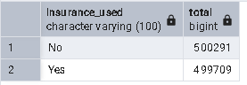

**11. Gender Distribution**

**SELECT GENDER, COUNT(*) AS TOTAL**

**FROM HEALTH**

**GROUP BY GENDER**

**ORDER BY TOTAL DESC**

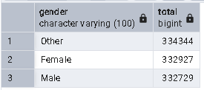

**12. Patient Country Distribution**

**SELECT COUNTRY, COUNT(*)**

**AS TOTAL**

**FROM HEALTH**

**GROUP BY COUNTRY**

**ORDER BY TOTAL DESC**

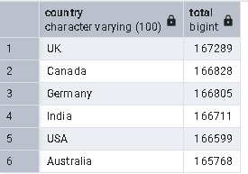

**13. Most Prescribed Medications**

**SELECT MEDICATION, COUNT(MEDICATION) AS TOTAL**

**FROM HEALTH**

**GROUP BY MEDICATION**

**ORDER BY TOTAL DESC**

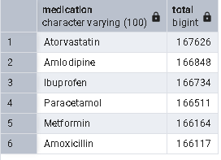

**14. Average Bill by Diagnosis**

